AI Observation (7-14)
7. Travelling Salesman Problem
Aim
To implement the Travelling Salesman Problem (TSP) using Python and determine the shortest possible route that visits every city exactly once and returns to the starting city.
Algorithm — Brute Force Approach
- Start with a set of cities and their distances.
- Select one city as the starting city.
- Generate all possible permutations of the remaining cities.
- For each permutation:
  - Calculate the total distance of the route.
  - Add the distance from the last city back to the starting city.
- Compare the distances of all possible routes.
- Select the route having the minimum total distance.
- Display the optimal route and minimum distance.
Code
from itertools import permutations
# Cities: A, B, C, D
distance = [
[0, 10, 15, 20],
[10, 0, 35, 25],
[15, 35, 0, 30],
[20, 25, 30, 0]
]
cities = ['A', 'B', 'C', 'D']
start = 0
min_distance = float('inf')
best_route = None
# Generate all possible routes
for perm in permutations(range(1, len(cities))):
route = (start,) + perm + (start,)
total_distance = 0
for i in range(len(route) - 1):
total_distance += distance[route[i]][route[i + 1]]
# Find minimum distance
if total_distance < min_distance:
min_distance = total_distance
best_route = route
# Display result
print("Travelling Salesman Problem")
print("--------------------------------")
print("Optimal Route:", end=" ")
for i in best_route:
print(cities[i], end=" ")
print("\nMinimum Distance:", min_distance)
Output
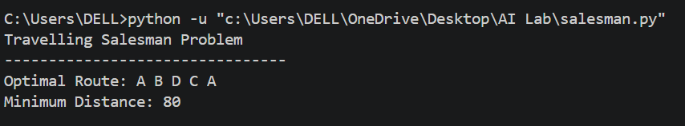
5. Result
Thus, the Travelling Salesman Problem was successfully implemented using Python. The optimal route obtained is:
A → B → D → C → A
with a minimum travelling distance of 80 units.

- Write the python program to implement A* algorithm

Aim
To write and implement a Python program for the A* (A-star) search algorithm to find the shortest path between a starting node and a goal node using the cost function and heuristic function.

Algorithm
- Start with the initial node.
- Add the initial node to the OPEN list.
- Calculate f(n) = g(n) + h(n).
- Select the node having the lowest f(n).
- If the selected node is the goal, stop and display the path.
- Otherwise, expand the selected node and find its neighboring nodes.
- Calculate the cost for each neighbor.
- Update the cost and parent of a neighbor if a better path is found.
- Repeat the process until the goal is reached.
- Display the shortest path and its total cost.

Code
import heapq
def a_star(graph, heuristic, start, goal):
open_list = []
heapq.heappush(open_list, (0, start))
g_cost = {start: 0}
parent = {start: None}
while open_list:
current_f, current = heapq.heappop(open_list)
if current == goal:
path = []
while current is not None:
path.append(current)
current = parent[current]
path.reverse()
return path, g_cost[goal]
for neighbor, cost in graph[current]:
new_g_cost = g_cost[current] + cost
if neighbor not in g_cost or new_g_cost < g_cost[neighbor]:
g_cost[neighbor] = new_g_cost
parent[neighbor] = current
f_cost = new_g_cost + heuristic[neighbor]
heapq.heappush(open_list, (f_cost, neighbor))
return None, float("inf")
graph = {
'A': [('B', 1), ('C', 4)],
'B': [('A', 1), ('C', 2), ('D', 5)],
'C': [('A', 4), ('B', 2), ('D', 1)],
'D': [('B', 5), ('C', 1), ('E', 3)],
'E': [('D', 3)]
}
heuristic = {
'A': 7,
'B': 6,
'C': 2,
'D': 1,
'E': 0
}
start = 'A'
goal = 'E'
path, cost = a_star(graph, heuristic, start, goal)
print("A* Algorithm")
print("----------------------")
print("Start Node:", start)
print("Goal Node:", goal)
print("Shortest Path:", " -> ".join(path))
print("Total Cost:", cost)

Output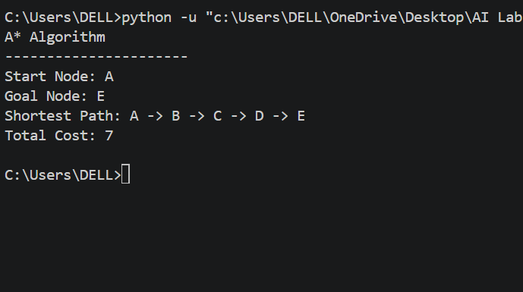

Result
Thus, the A* algorithm was successfully implemented using Python. The shortest path from the starting node A to the goal node E is:
A → B → C → D → E
The minimum path cost is 7.

- Write the python program for Map Coloring to implement CSP
Aim
To write and implement a Python program for Map Coloring using Constraint Satisfaction Problem (CSP), where adjacent regions are assigned different colors.
Algorithm
- Define the regions of the map.
- Define the neighboring regions using constraints.
- Define a set of available colors.
- Select an uncolored region.
- Assign a color to the selected region.
- Check whether the assigned color conflicts with any neighboring region.
- If there is no conflict, continue with the next region.
- If a conflict occurs, backtrack and try another color.
- Continue until all regions are colored.
- Display the final map coloring solution.

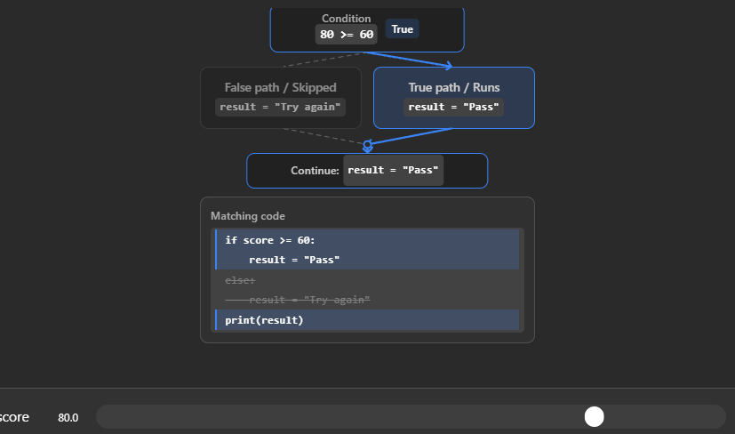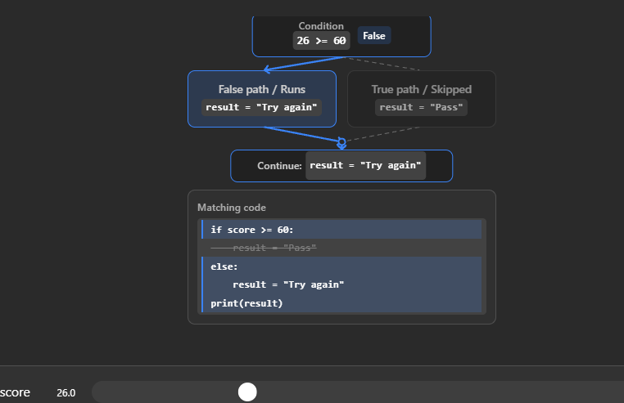
Code
# Map regions
regions = ['A', 'B', 'C', 'D']
colors = ['Red', 'Green', 'Blue']
neighbors = {
'A': ['B', 'C'],
'B': ['A', 'C', 'D'],
'C': ['A', 'B', 'D'],
'D': ['B', 'C']
}
def is_valid(region, color, assignment):
for neighbor in neighbors[region]:
if neighbor in assignment and assignment[neighbor] == color:
return False
return True
def map_coloring(assignment):
if len(assignment) == len(regions):
return assignment
region = next(r for r in regions if r not in assignment)
for color in colors:
if is_valid(region, color, assignment):
assignment[region] = color
result = map_coloring(assignment)
if result:
return result
del assignment[region]
return None
solution = map_coloring({})
print("Map Coloring using CSP")
print("----------------------")

if solution:
for region, color in solution.items():
print(region, ":", color)
else:
print("No solution exists.")

Output
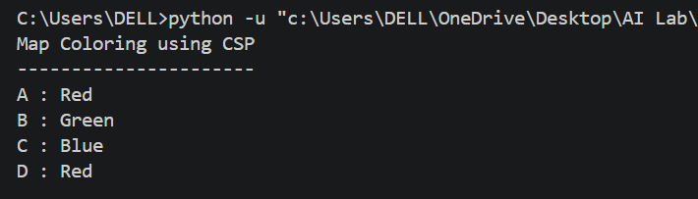

Result
Thus, the Map Coloring problem was successfully implemented using the Constraint Satisfaction Problem (CSP) technique in Python.
The obtained coloring is:
- A → Red
- B → Green
- C → Blue
- D → Red
No two adjacent regions have the same color, so the CSP constraints are satisfied successfully.

- Write the python program for Tic Tac Toe game
Aim
To write and implement a Python program for the Tic Tac Toe game, where two players take turns placing X and O on a 3×3 board, and the player who gets three symbols in a row, column, or diagonal wins.
Algorithm
- Create a 3×3 Tic Tac Toe board.
- Initialize all positions as empty.
- Display the board.
- Set the first player as X.
- Ask the player to enter a position from 1 to 9.
- Check whether the selected position is empty.
- Place the player's symbol in that position.
- Check whether the player has three symbols in a row, column, or diagonal.
- If a player wins, display the winner and stop the game.
- If all positions are filled without a winner, declare the game as a draw.
- Otherwise, switch to the other player and continue.
Code
# Tic Tac Toe Game
board = [' ' for _ in range(9)]
def display_board():
print()
print(board[0], '|', board[1], '|', board[2])
print('--+---+--')
print(board[3], '|', board[4], '|', board[5])
print('--+---+--')
print(board[6], '|', board[7], '|', board[8])
print()
def check_winner(player):
winning_positions = [
(0, 1, 2),
(3, 4, 5),
(6, 7, 8),
(0, 3, 6),
(1, 4, 7),
(2, 5, 8),
(0, 4, 8),
(2, 4, 6)
]
for a, b, c in winning_positions:
if board[a] == board[b] == board[c] == player:
return True
return False
player = 'X'
print("TIC TAC TOE")
print("Positions are numbered from 1 to 9.")
for turn in range(9):
display_board()
print("Player", player, "turn")
while True:
try:
position = int(input("Enter position (1-9): "))
if position < 1 or position > 9:
print("Please enter a number between 1 and 9.")
elif board[position - 1] != ' ':
print("Position already occupied. Try again.")
else:
break
except ValueError:
print("Please enter a valid number.")
board[position - 1] = player
if check_winner(player):
display_board()
print("Player", player, "wins!")
break
player = 'O' if player == 'X' else 'X'
else:
display_board()
print("The game is a draw!")7
Output
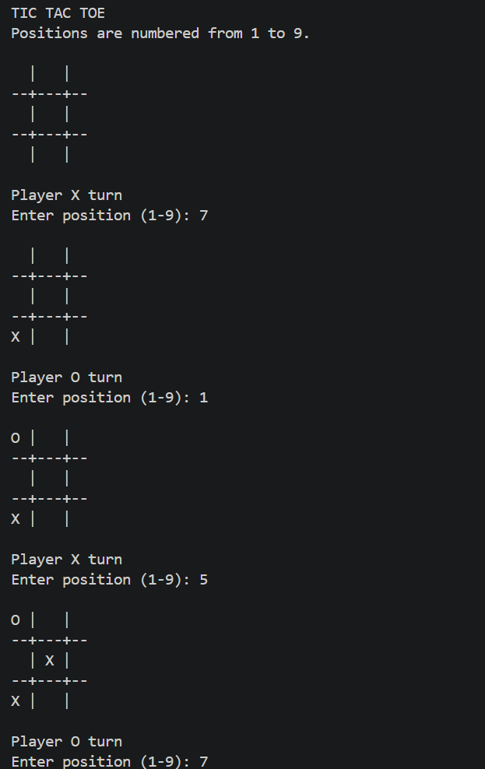
Result
Thus, the Tic Tac Toe game was successfully implemented using Python. The program allows two players to play alternately, checks all possible winning combinations, and displays the winner or draw result.
- Write the python program to implement Minimax algorithm for gaming
Aim
To write and implement a Python program for the Minimax algorithm in gaming. The algorithm helps the computer choose the best possible move by evaluating all possible game states.
Algorithm
- Create a Tic-Tac-Toe game board.
- Define the winning combinations.
- Check whether the current game state is a win, loss, or draw.
- Generate all possible moves.
- For each possible move, recursively call the Minimax function.
- Assign scores:
  - +10 if the computer wins.
  - -10 if the human player wins.
  - 0 if the game is a draw.
- The computer selects the move with the maximum score.
- The human player is considered the minimizing player.
- Continue until the game reaches a final state.
- Display the winner or draw.

Code
# Minimax Algorithm for Gaming
board = [' ' for _ in range(9)]
def display_board():
print()
print(board[0], '|', board[1], '|', board[2])
print('--+---+--')
print(board[3], '|', board[4], '|', board[5])
print('--+---+--')
print(board[6], '|', board[7], '|', board[8])
print()
def check_winner(player):
winning_positions = [
(0, 1, 2),
(3, 4, 5),
(6, 7, 8),
(0, 3, 6),
(1, 4, 7),
(2, 5, 8),
(0, 4, 8),
(2, 4, 6)
]
for a, b, c in winning_positions:
if board[a] == board[b] == board[c] == player:
return True
return False
def is_full():
return ' ' not in board
def minimax(is_maximizing):
if check_winner('O'):
return 10
if check_winner('X'):
return -10
if is_full():
return 0
if is_maximizing:
best_score = -float('inf')
for i in range(9):
if board[i] == ' ':
board[i] = 'O'
score = minimax(False)
board[i] = ' '
best_score = max(best_score, score)
return best_score
# Minimizing player - Human
else:
best_score = float('inf')
for i in range(9):
if board[i] == ' ':
board[i] = 'X'
score = minimax(True)
board[i] = ' '
best_score = min(best_score, score)
return best_score
def find_best_move():
best_score = -float('inf')
best_move = -1
for i in range(9):
if board[i] == ' ':
board[i] = 'O'
score = minimax(False)
board[i] = ' '

if score > best_score:
best_score = score
best_move = i
return best_move
print("TIC TAC TOE - MINIMAX")
print("You = X")
print("Computer = O")
while True:
display_board()
while True:
try:
position = int(input("Enter position (1-9): "))

if position < 1 or position > 9:
print("Enter a number from 1 to 9.")

elif board[position - 1] != ' ':
print("Position already occupied.")
else:
break
except ValueError:
print("Enter a valid number.")
board[position - 1] = 'X'
# Check human winner
if check_winner('X'):
display_board()
print("Human wins!")
break
if is_full():
display_board()
print("Game Draw!")
break
move = find_best_move()
board[move] = 'O'
print("Computer chooses position:", move + 1)
if check_winner('O'):
display_board()
print("Computer wins!")
break
if is_full():
display_board()
print("Game Draw!")
break

Output
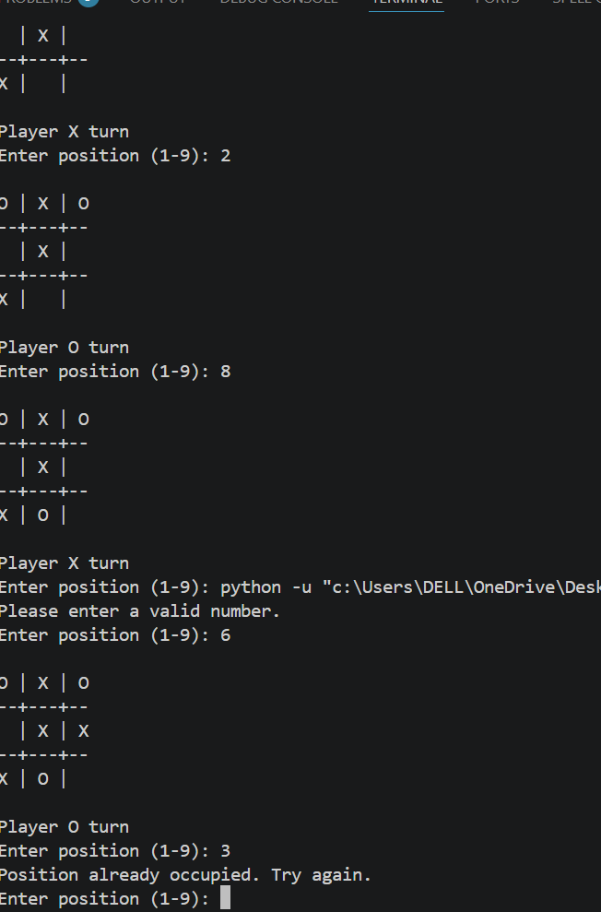
Result
Thus, the Minimax algorithm was successfully implemented using Python for gaming. The program evaluates the possible game states and enables the computer to select the optimal move. The program successfully identifies whether the human wins, computer wins, or the game ends in a draw.

12. Write the python program to implement Alpha & Beta pruning algorithm for gaming
Aim
To write and implement a Python program for the Alpha-Beta Pruning algorithm in gaming and determine the optimal move by eliminating branches that do not affect the final decision.
Algorithm
- Create a Tic-Tac-Toe game board.
- Define all possible winning combinations.
- Set the initial values:
  - Alpha = -∞
  - Beta = +∞
- Generate all possible moves.
- Apply the Minimax algorithm to evaluate each possible move.
- For the maximizing player:
  - Select the maximum score.
  - Update alpha.
- For the minimizing player:
  - Select the minimum score.
  - Update beta.
- If beta <= alpha, stop exploring that branch. This is called pruning.
- Select the move with the best score.
- Continue until the game ends.
- Display the winner or draw.

Code
board = [' ' for _ in range(9)]
def display_board():
print()
print(board[0], '|', board[1], '|', board[2])
print('--+---+--')
print(board[3], '|', board[4], '|', board[5])
print('--+---+--')
print(board[6], '|', board[7], '|', board[8])
print()
def check_winner(player):
winning_positions = [
(0, 1, 2),
(3, 4, 5),
(6, 7, 8),
(0, 3, 6),
(1, 4, 7),
(2, 5, 8),
(0, 4, 8),
(2, 4, 6)
]
for a, b, c in winning_positions:
if board[a] == board[b] == board[c] == player:
return True
return False
def is_full():
return ' ' not in board
def alpha_beta(is_maximizing, alpha, beta):
if check_winner('O'):
return 10
# Human wins
if check_winner('X'):
return -10
if is_full():
return 0
if is_maximizing:
best_score = -float('inf')
for i in range(9):
if board[i] == ' ':
board[i] = 'O'
score = alpha_beta(False, alpha, beta)
board[i] = ' '
best_score = max(best_score, score)
alpha = max(alpha, best_score)
if beta <= alpha:
break
return best_score
else:
best_score = float('inf')
for i in range(9):
if board[i] == ' ':
board[i] = 'X'
score = alpha_beta(True, alpha, beta)
board[i] = ' '
best_score = min(best_score, score)
beta = min(beta, best_score)
if beta <= alpha:
break
return best_score
def find_best_move():
best_score = -float('inf')
best_move = -1
alpha = -float('inf')
beta = float('inf')
for i in range(9):
if board[i] == ' ':
board[i] = 'O'
score = alpha_beta(False, alpha, beta)
board[i] = ' '
if score > best_score:
best_score = score
best_move = i
return best_move
print("TIC TAC TOE - ALPHA-BETA PRUNING")
print("You = X")
print("Computer = O")
while True:
display_board()
while True:
try:
position = int(input("Enter position (1-9): "))
if position < 1 or position > 9:
print("Enter a number between 1 and 9.")
elif board[position - 1] != ' ':
print("Position already occupied.")
else:
break
except ValueError:
print("Enter a valid number.")
board[position - 1] = 'X'
if check_winner('X'):
display_board()
print("Human wins!")
break
if is_full():
display_board()
print("Game Draw!")
break
move = find_best_move()
board[move] = 'O'
print("Computer chooses position:", move + 1)
if check_winner('O'):
display_board()
print("Computer wins!")
break
if is_full():
display_board()
print("Game Draw!")
break

Output
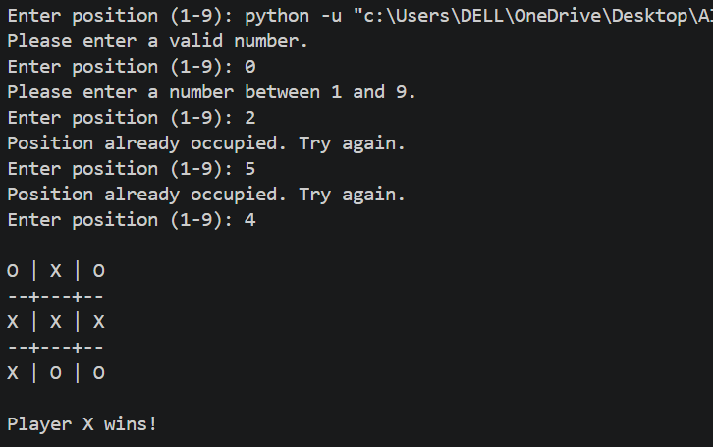
Result
Thus, the Alpha-Beta Pruning algorithm was successfully implemented using Python for gaming. The program evaluates the possible moves and eliminates unnecessary branches using Alpha and Beta values, allowing the computer to efficiently select the optimal move.
13. Write the python program to implement decision tree
Aim
To write and implement a Python program for Decision Tree classification and predict the class of new data using the Decision Tree algorithm.
Algorithm
- Import the required Python libraries.
- Create a dataset containing input features and target classes.
- Separate the dataset into input (X) and output (y).
- Create a Decision Tree Classifier.
- Train the classifier using the training data.
- Provide a new sample for prediction.
- Use the trained Decision Tree to predict its class.
- Display the predicted result.

Code
from sklearn.tree import DecisionTreeClassifier
X = [
[1, 1],
[1, 0],
[0, 1],
[0, 0],
[1, 1],
[0, 0]
]
y = ['Yes', 'Yes', 'No', 'No', 'Yes', 'No']
model = DecisionTreeClassifier(criterion='entropy', random_state=0)
model.fit(X, y)
test = [[1, 1]]
prediction = model.predict(test)
print("Decision Tree")
print("----------------")
print("Test Data:", test)
print("Predicted Class:", prediction[0])
Output
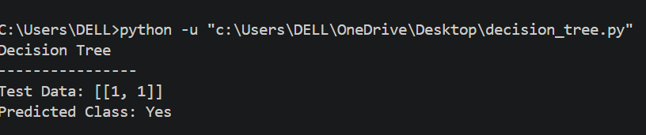
Result
Thus, the Decision Tree classification algorithm was successfully implemented using Python. The trained model successfully classified the given test data and predicted the class as Yes.

14. Write the python program to implement Feed forward neural Network
Aim
To write and implement a Python program for a Feed Forward Neural Network (FFNN) to classify input data into different classes.
Algorithm
- Import the required libraries.
- Create the input dataset and target values.
- Divide the dataset into training and testing data.
- Create a Feed Forward Neural Network using MLPClassifier.
- Train the network using the training data.
- Give new input data to the trained network.
- Predict the class of the input.
- Display the predicted result.
Code
from sklearn.neural_network import MLPClassifier

X = [
[0, 0],
[0, 1],
[1, 0],
[1, 1]
]
y = [0, 0, 0, 1]
model = MLPClassifier(
hidden_layer_sizes=(5,),
activation='relu',
solver='lbfgs',
max_iter=5000,
random_state=42
)
model.fit(X, y)
test_data = [
[0, 0],
[0, 1],
[1, 0],
[1, 1]
]
prediction = model.predict(test_data)
print("Feed Forward Neural Network")
print("---------------------------")
for i in range(len(test_data)):
print("Input:", test_data[i],
"Predicted Output:", prediction[i])
Output
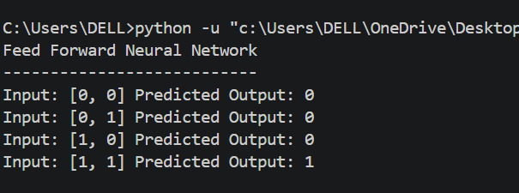
Result
Thus, the Feed Forward Neural Network was successfully implemented using Python. The trained neural network successfully classified the test input [1, 1] and predicted the output as 1.

